**GAAM Reporting**

This article was updated to support v11.9 of Goliath Performance Monitor & Application Availability Monitor.

With the Goliath Application Availability Monitor (GAAM), data can be retained in the database for an unlimited amount of time. The purpose of this document is review the process of configuring historical reports. These reports can be scheduled or ran on-demand, and will list all the launches that succeeded or failed and will also contain a copy of all the logs in collapsible frames.

**Creating a Report**

1. From the Report page, click mceclip1.png in the top right corner of the page to open the Report Dialog.
2. Select the report type radio button for  "Alert & Log Analysis", chose the report template "Alert Analysis" and click **Next**.   
     
   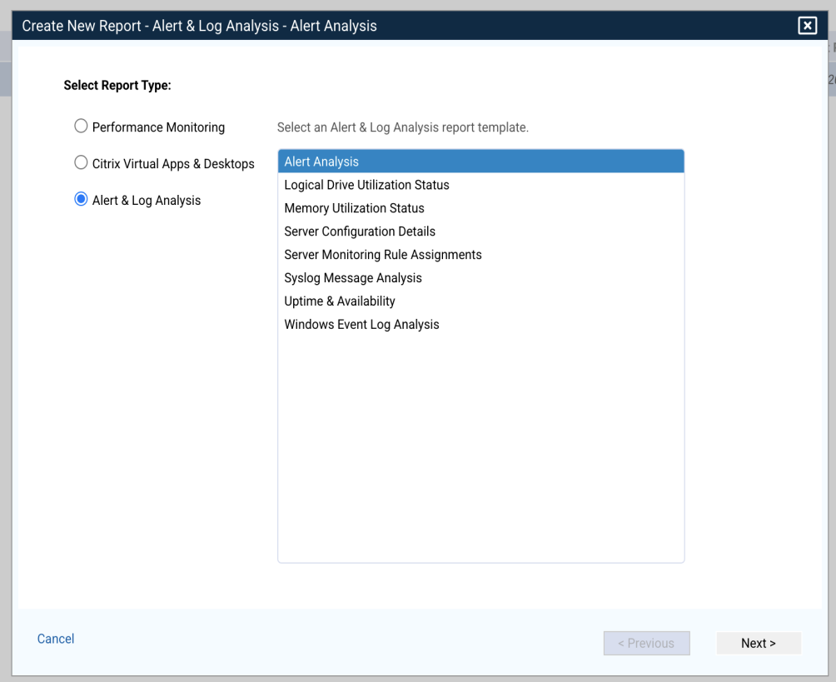
3. After selecting a template, select the option for "GAAM Alerts" and click next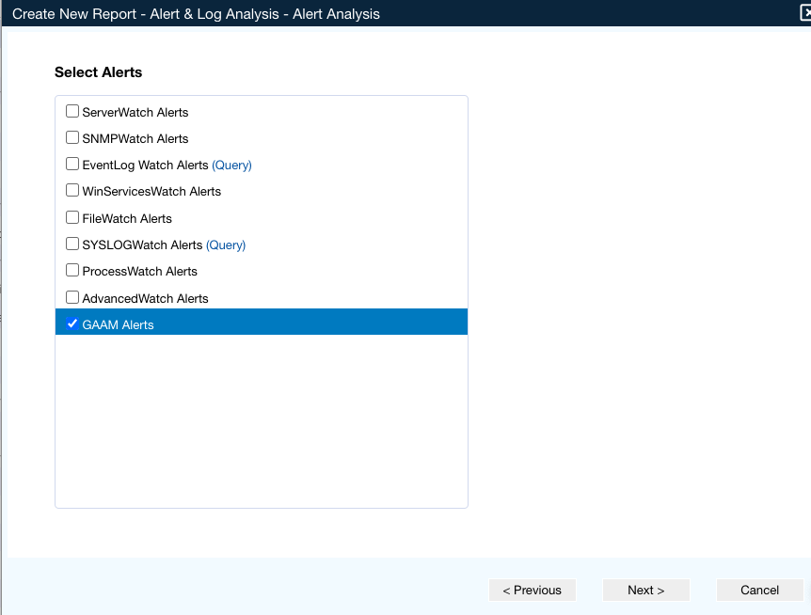
4. After selecting a template and the required report options, select the GAAM launches and/or endpoints devices to report on.  
     
   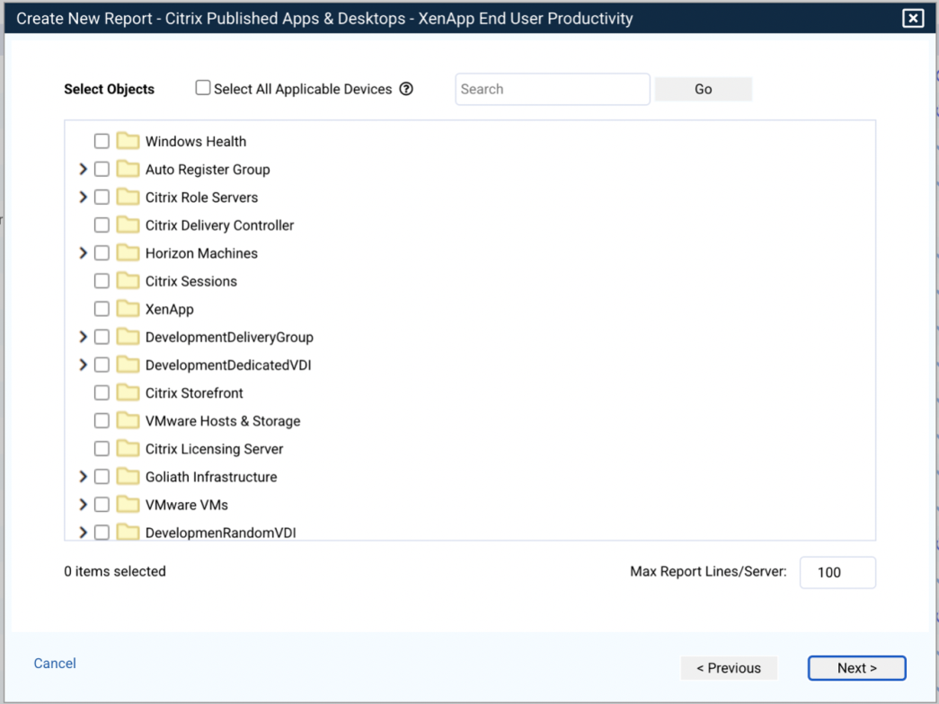  
     
   Check **Select All Applicable Devices**to automatically select all GAAM launches and endpoint devices to report on.  
     
   Please note, a lot of information may be included for each selected device. You can limit the amount of data to display for each device using the **Max Report/Lines Server** option.  
     
   After selecting the devices or groups to include, click **Next.**
5. Next, give the report a name and description and optionally assign a report owner. The report owner is displayed on the main report page to help you organize and view your available reports.  
     
   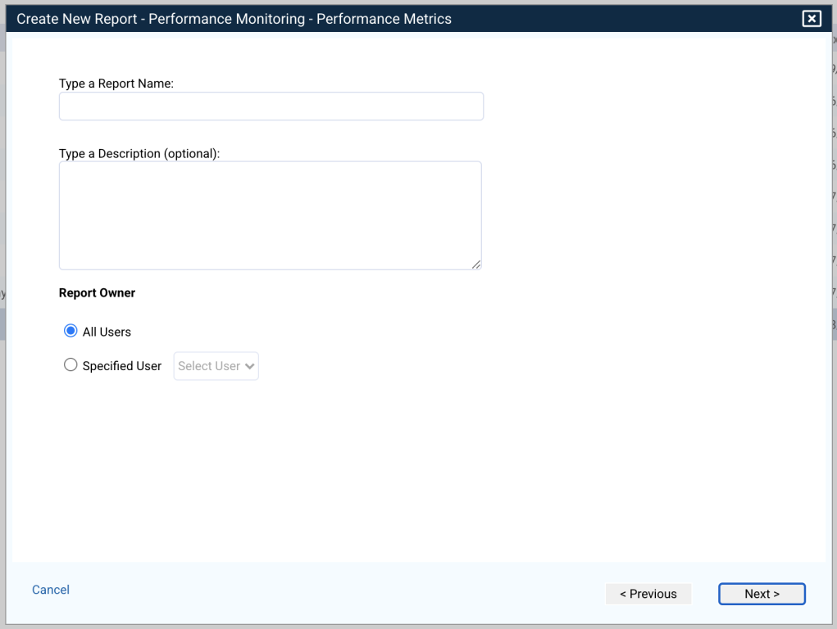  
     
   Click **Next.**
6. At the next step you will define your sharing options. Reports can be emailed or exported each time they are run. You can select to send the report as a PDF or CSV file. For reports to be emailed, SMTP settings must be configured.  
     
   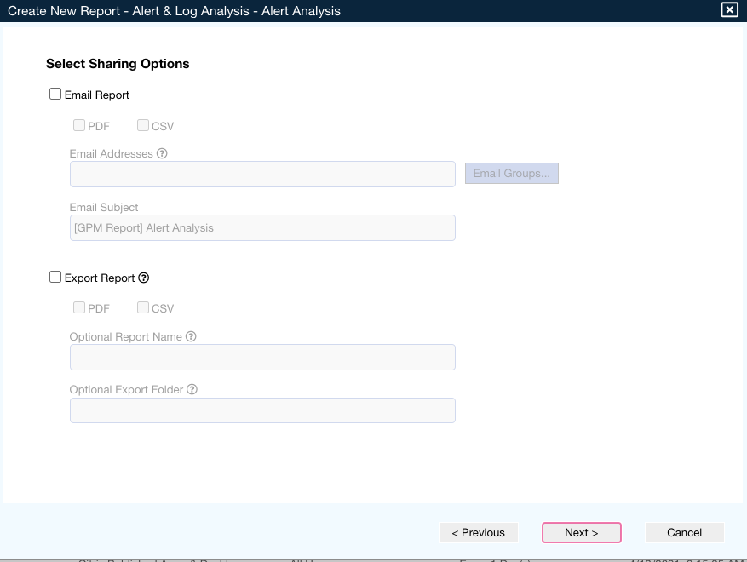  
     
   Click **Next.**
7. Finally, select how often to run the report and the timeframe to include each time the report runs.  
     
   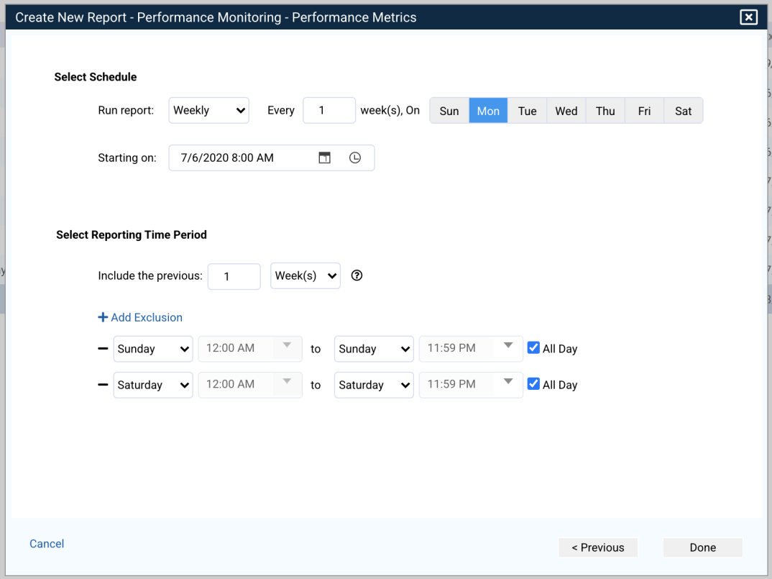  
     
   For example, to run a weekly report that includes the last week of data each time, you would select to run the report every Friday at 5pm and include the last 5 days. If you wanted to run the report on Sunday night, you could include the last 7 days and then exclude Saturday and Sunday using the options available.  
     
   You also have the option to create a report without a schedule by selecting **On** **Demand**. This lets you run the report anytime you need using the template and options selected.
8. Click **Done** to finish creating the report. The new report is displayed in the main report table.